
Healthcare Management: Patient Readmission Prediction
IG DA: Capstone Project
Akansha Chowdhury |  | Course-end Project 2

IG DA: Capstone Project – 2
Healthcare Management: Patient Readmission Prediction

The goal of this project is to analyse the likelihood of a patient being readmitted to a healthcare facility within 30 days after discharge. By identifying high-risk patients through data-driven analysis, the project aims to empower healthcare providers to proactively intervene. The expected outcome is to support the delivery of proactive and personalized care, ultimately enhancing the overall quality of care and achieving a measurable reduction in both readmission rates and healthcare costs.
To achieve these goals, the project analyse a comprehensive dataset of patient demographics, medical history, and clinical encounters. The analysis is executed through a multi-platform approach, utilizing Excel for statistical summaries, SQL for data extraction, Python for deep exploratory analysis, and Tableau for interactive visualization. These tools work together to identify high-risk patterns and provide actionable insights for healthcare management.
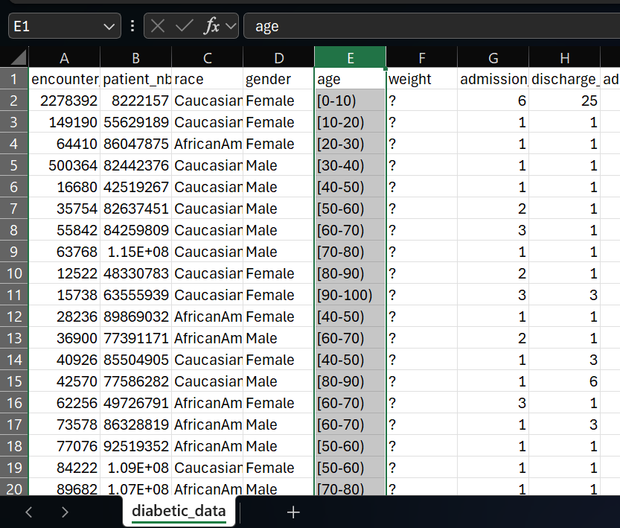
Prior to performing the task, the provided dataset diabetic_data.csv was reviewed. The age column had an issue as we can see below the values are mentioned as [0-10) , [10_20) and so on. To make it in correct format (0-10), (10-20), here I have replaced the ‘]’ into ‘)’.
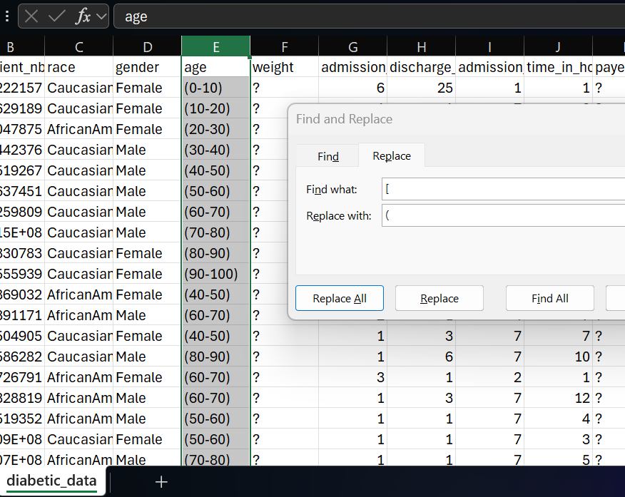

The following steps are followed to complete the task-

Excel Task:
- Data Exploration:
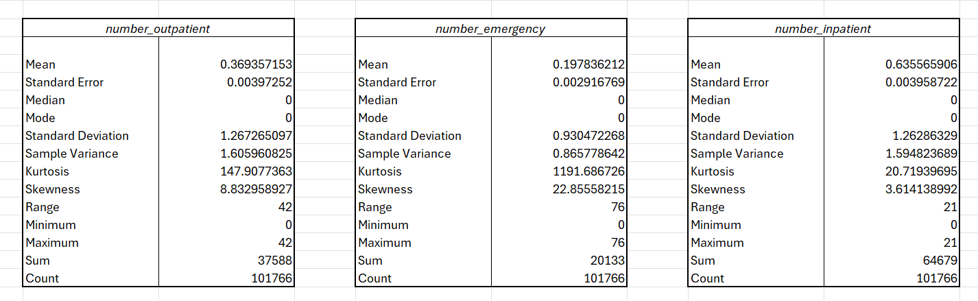
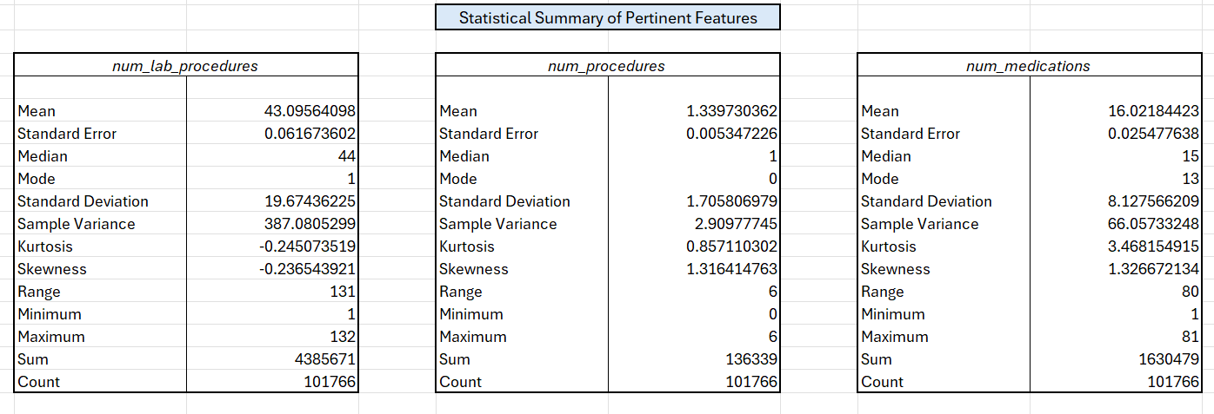
- To make a statistical summary of pertinent features like the number of lab procedures, procedures, drugs, and furthermore.

Used the Descriptive Statistics tool in the Data Analysis Tool to generate a statistical summary of lab procedures, medications, and other numerical features as mentioned above in a new sheet called “Statistical Summary”.

Gender with age group | Total number of readmission
Female | 54708
(0-10) | 83
(10-20) | 402
(20-30) | 1114
(30-40) | 2162
(40-50) | 4811
(50-60) | 8572
(60-70) | 11061
(70-80) | 13985
(80-90) | 10515
(90-100) | 2003
Male | 47055
(0-10) | 78
(10-20) | 289
(20-30) | 543
(30-40) | 1613
(40-50) | 4874
(50-60) | 8684
(60-70) | 11421
(70-80) | 12081
(80-90) | 6682
(90-100) | 790
Unknown/Invalid | 3
(60-70) | 1
(70-80) | 2
(blank)
(blank)
Grand Total | 101766
- To create a report showing the number of readmissions by gender and age group
Used Pivot Table to create table with gender and age in the rows and a count of readmissions in the values to summarize patient outcomes.

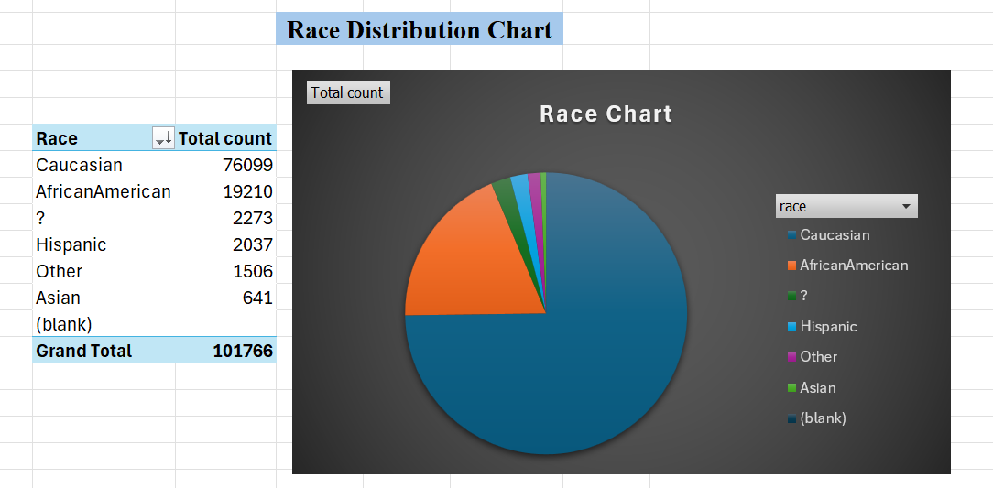
- To show race distribution in a chart
A Pie Chart is created using Pivot Table based on a frequency count of the race column to visualize the race distribution.
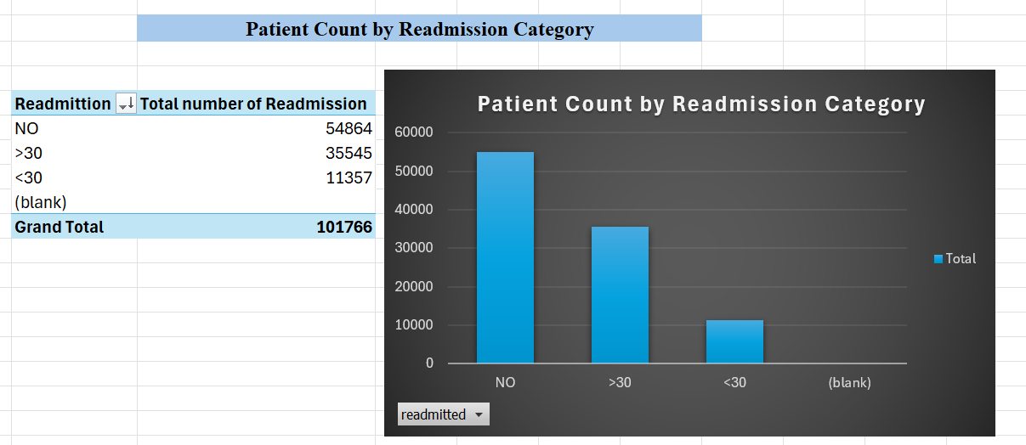
- To plot count of patients for each category of readmitted

Used Pivot Table to create a Bar Chart to plot the total count of patients for each of the three readmission categories.
The Excel analysis established essential statistical benchmarks and identified readmission trends across key demographics like age, gender, and race. These visualizations provide a foundational baseline of the patient population.

SQL Task:
- Data Loading:
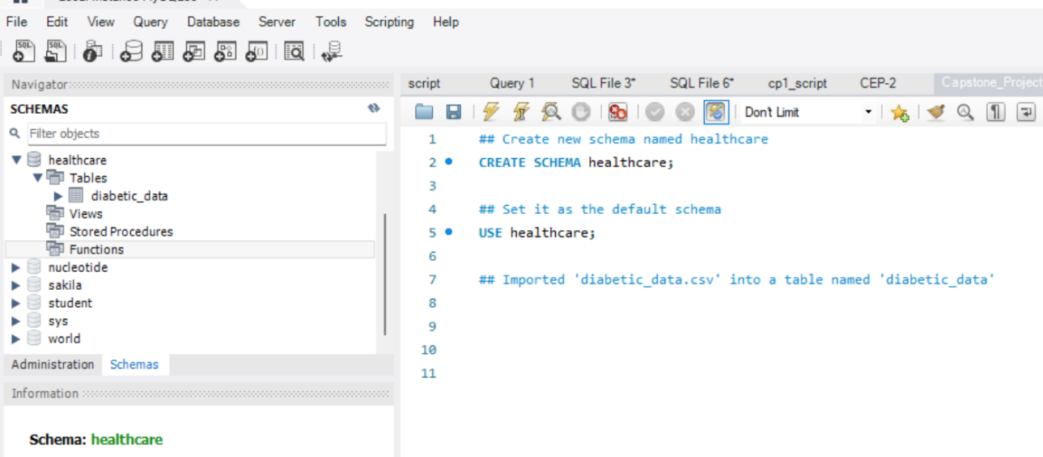
- A new Schema named healthcare was created and table was created using diabetic_data.csv.

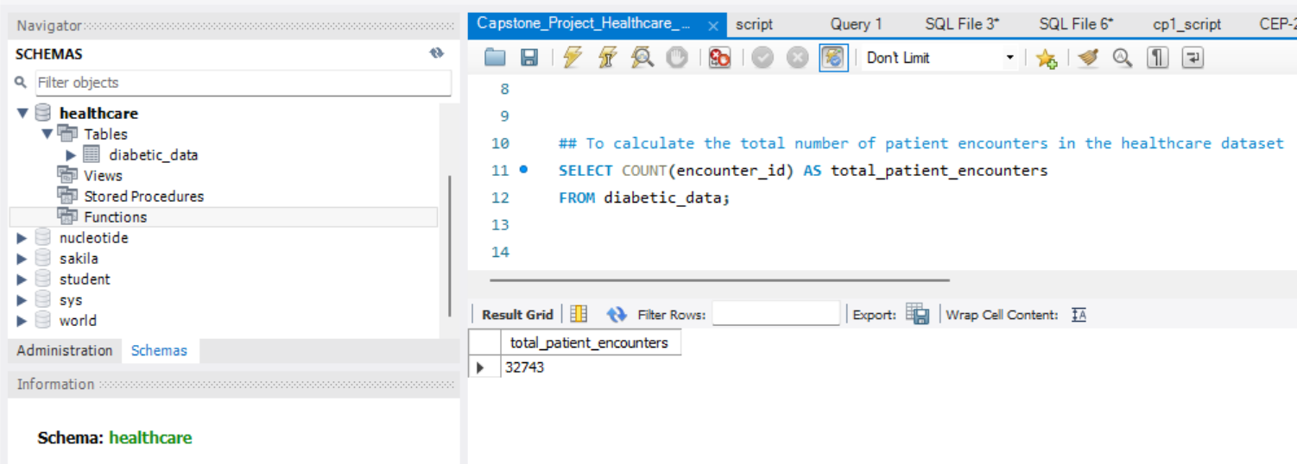
- To calculate the total number of patient encounters in the healthcare dataset using COUNT() function. The total patient encounters is 32743.

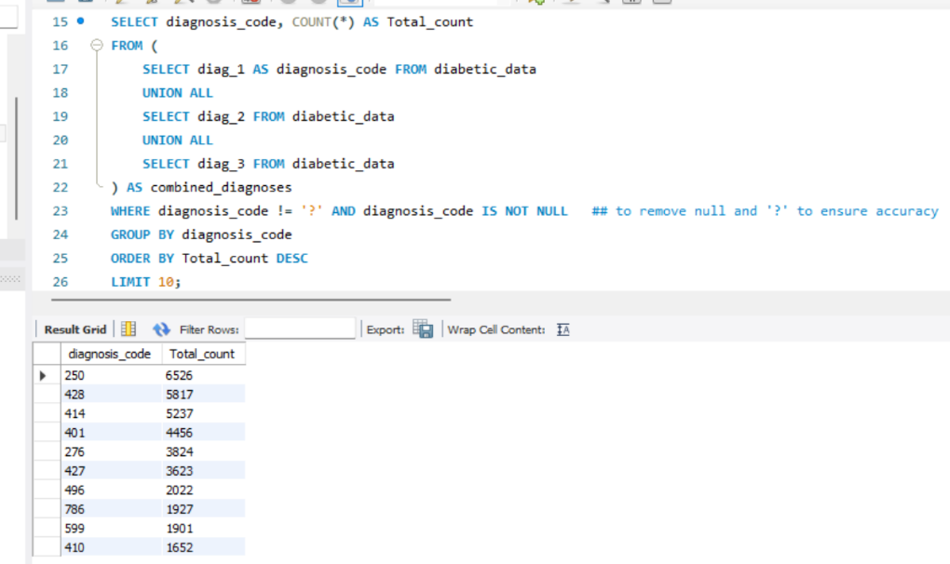
- To identify the top 10 most frequent diagnoses in the dataset

Here UNION ALL is used to combine results from multiple columns as we analyze the medical codes in diag_1, diag_2, and diag_3 into a single list without removing any duplicate entries. This is essential for frequency analysis because it preserves every occurrence of a diagnosis code, allowing for an accurate total count across all patient records.
Here we can see the diagnosis code 250 has the highest count as compared to others.
- To calculate the average length of hospital stay for each admission type
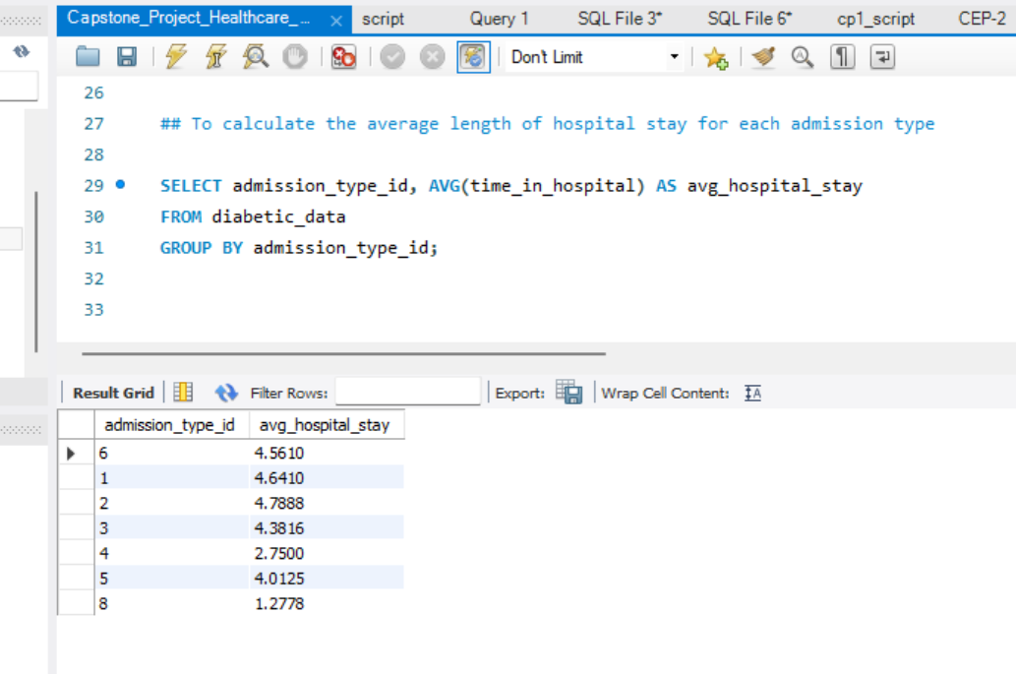
The Admission_type_id ‘2’ has the highest average length of hospital stay and Admission_type_id ‘8’ has the lowest average length of hospital stay.

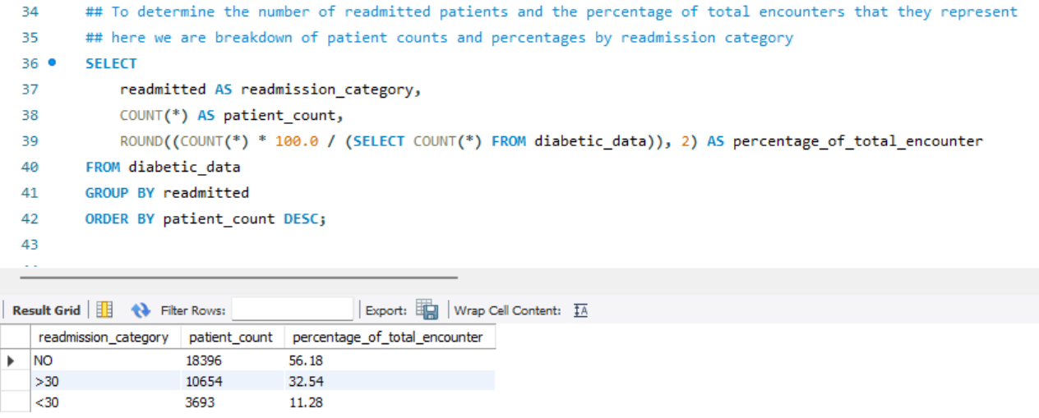
- To determine the number of readmitted patients and the percentage of total encounters that they represent
patient_count : represents the number of readmitted patients.
Here 18396 patients approx. 56.18% of total encounter have not taken readmission and approx. 11.28% of total encounter (3693 encounter) have taken readmission more than 30 times.
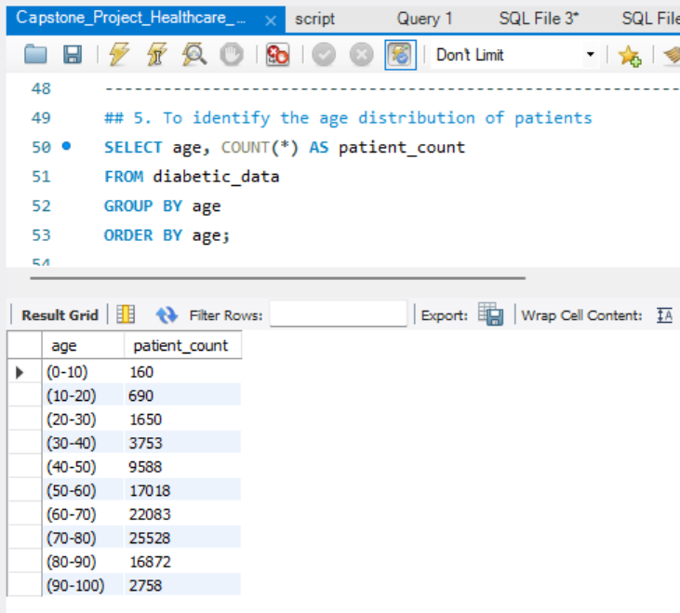
- To identify the age distribution of patients
The highest patient count is from the age group (70-80) and lowest is from the age group (0-10).
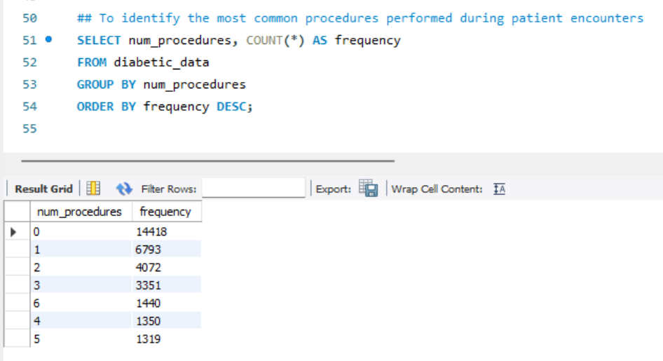
- To identify the most common procedures performed during patient encounters
The num_procedures id 0 was done more frequently than num_procedures id 5.
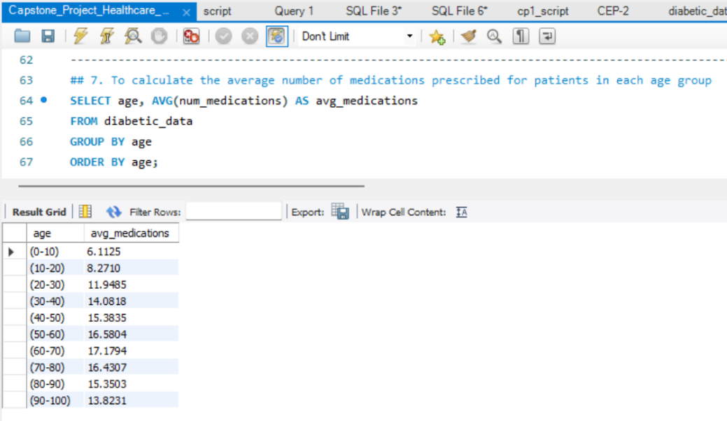
- To calculate the average number of medications prescribed for patients in each age group
The Highest average number of medications prescribed to age group (60-70) and the lowest average number of medications prescribed to age group (0-10).
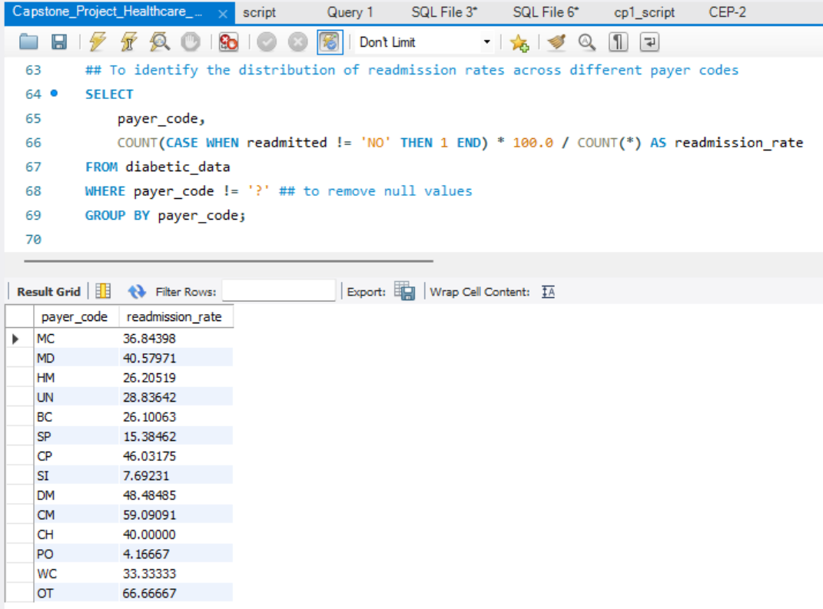
- To identify the distribution of readmission rates across different payer codes

The highest readmission rates across the payer codes is of ‘OT’ – 66.66667 and lowest readmission rates across the payer codes is of ‘PO’ - 4.16667.

Python Task:
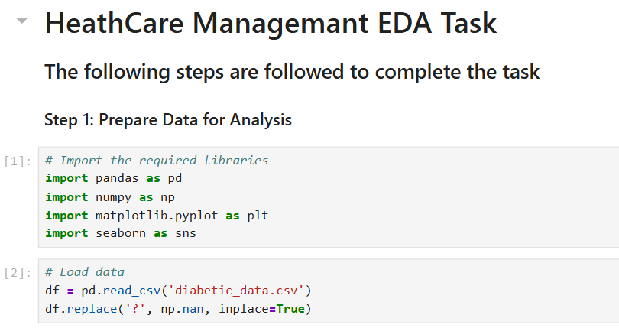
- EDA Task:
Preparation of data and Importing required libraries for the analysis.

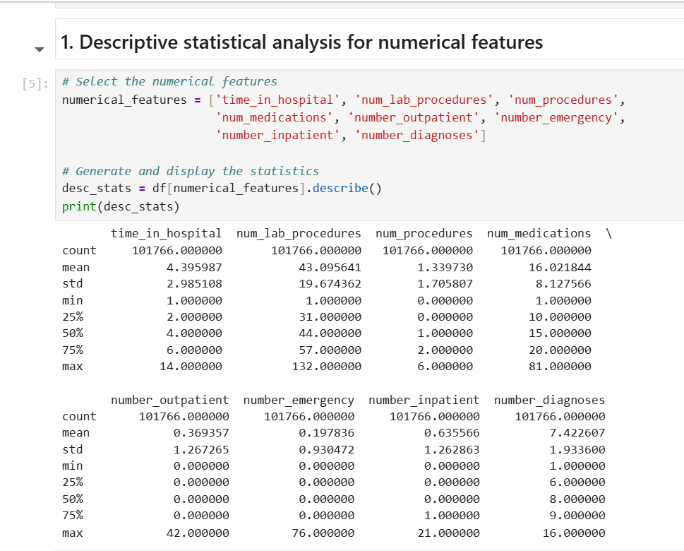
- To perform descriptive statistical analysis for numerical features

The above analysis shows us that diabetic patients usually have a long stay. On average, a patient stays about 4 days, takes 16 different medicines, has 43 lab tests and with over 7 different diagnoses listed per person.

- To visualize the distribution of categorical features - race and gender
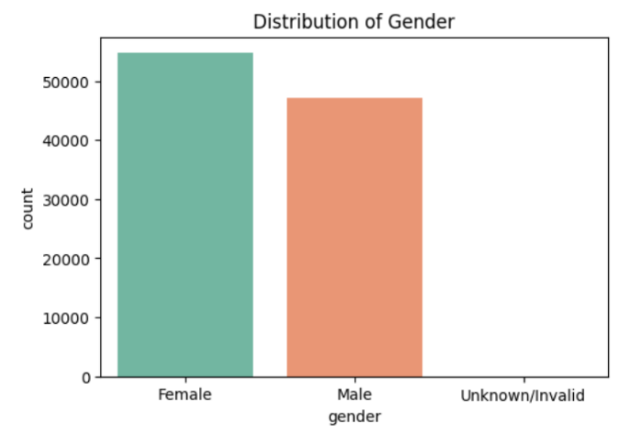
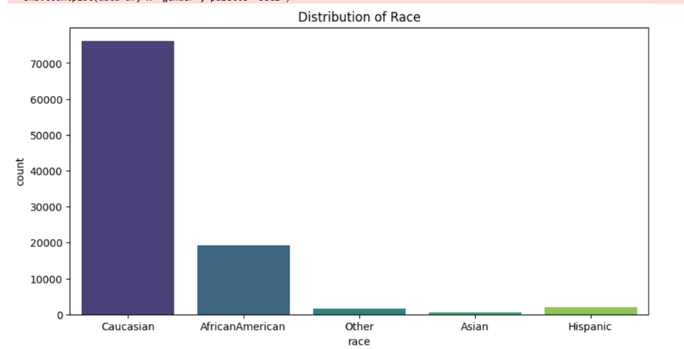
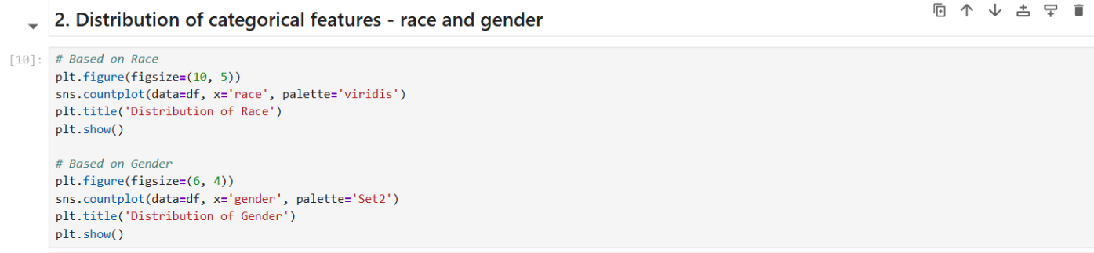
Most patients in this dataset are Caucasian, followed by African American. There is a fairly equal split between men and women.
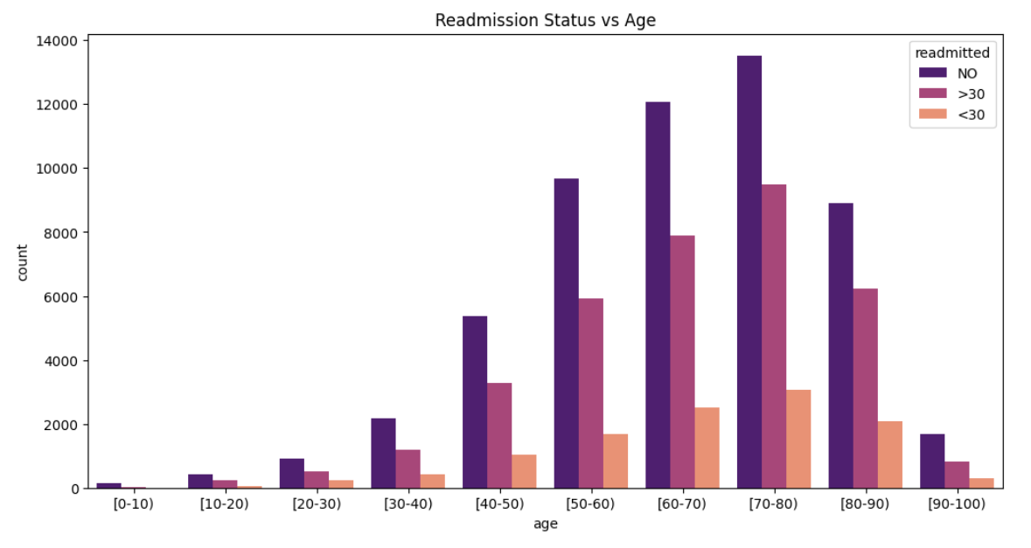
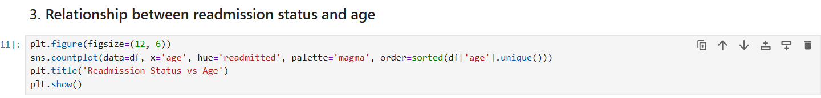
- To explore the relationship between readmission status and age
As patients get older (especially those over 70 years old), they are much more likely to return to the hospital within 30 days. This means the hospital needs to pay extra attention to elderly patients.

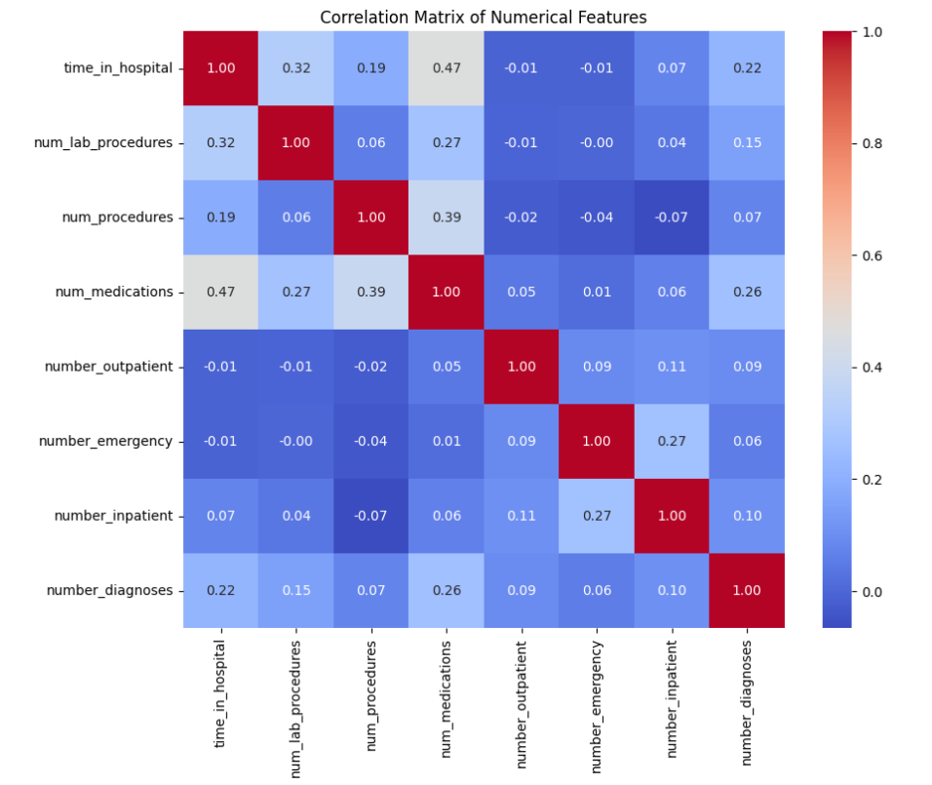
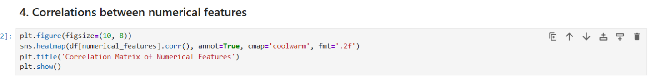
- To investigate correlations between numerical features

From the above correlation matrix, we can infer that the longer a patient stays in the hospital, the more medications they are given as a moderate positive correlation (0.47) exists between the length of stay and the number of medications prescribed. Interestingly, lab procedures show a weaker correlation with stay duration (0.32), suggesting that intensive diagnostic testing often occurs early in the admission regardless of the total time spent in the hospital.

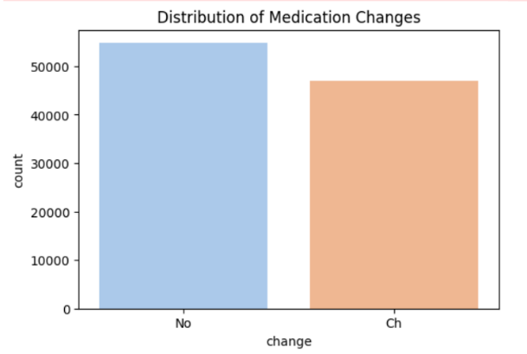
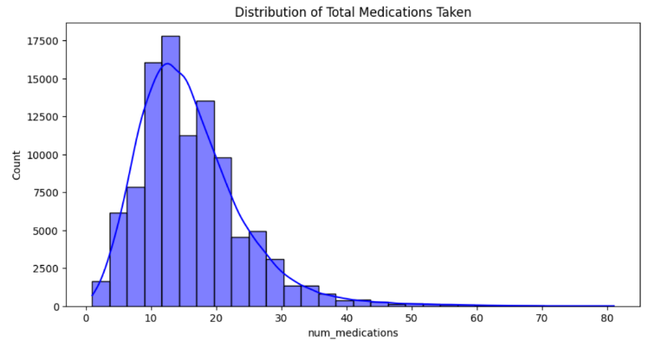
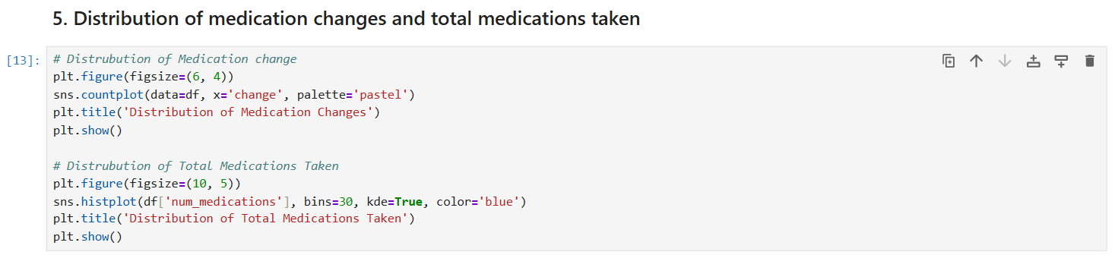
- To analyze the distribution of medication changes and total medications taken

About half of all patients experienced a change (Ch) in their diabetic medication dosage or type, reflecting the acute nature of these encounters.
The right-skewed distribution of total medications shows that many patients come to the hospital because their diabetes is not currently under control.
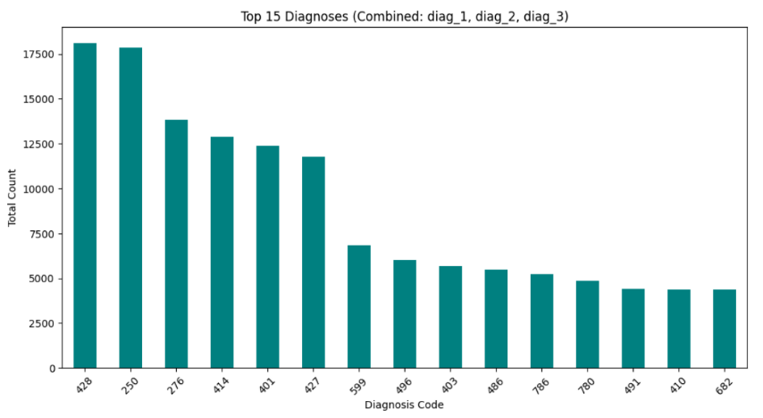
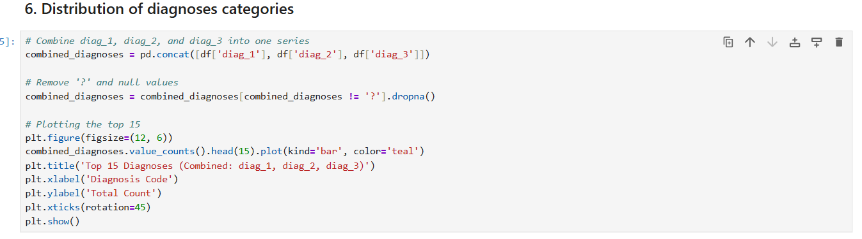
- To examine the distribution of diagnoses categories
By combining all the diagnoses in the dataset (diag_1, diag_2, diag_3) most of the patient are diagnosed with code 428 , 250 which we can infer form the above bar graph of top 15 diagnoses.
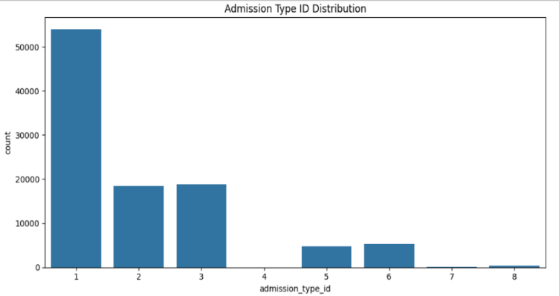
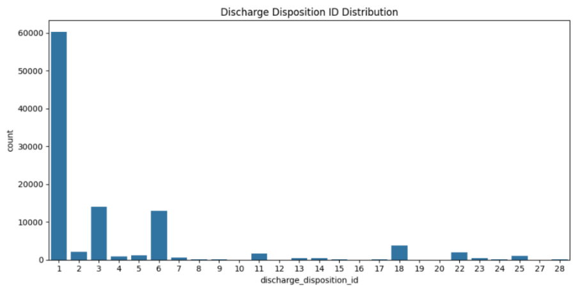
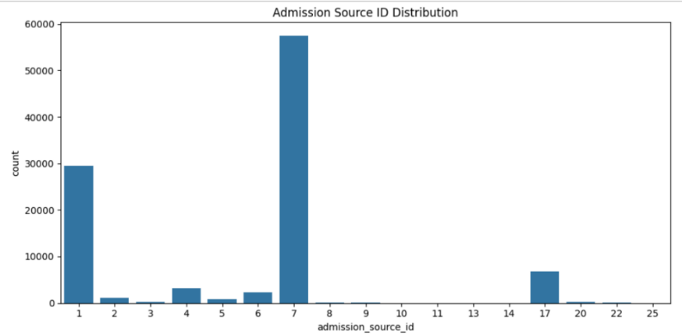
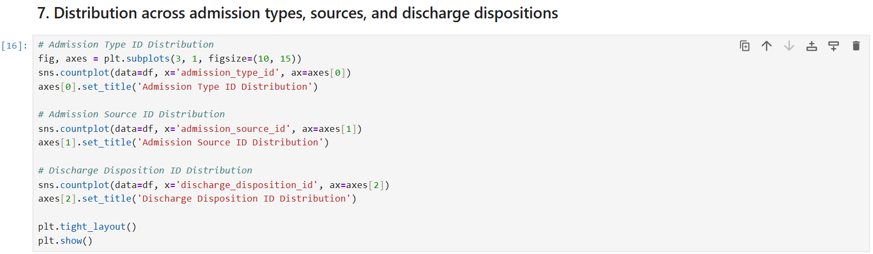
- To explore the distribution of patients across admission types, sources, and discharge dispositions

By looking at these three charts together, we can see that on average patient arrives through the Emergency Room in an urgent state and usually goes home afterward. However, the smaller bars represent the High-Risk Group that the healthcare management system which needs to watch most closely to prevent them from coming back.
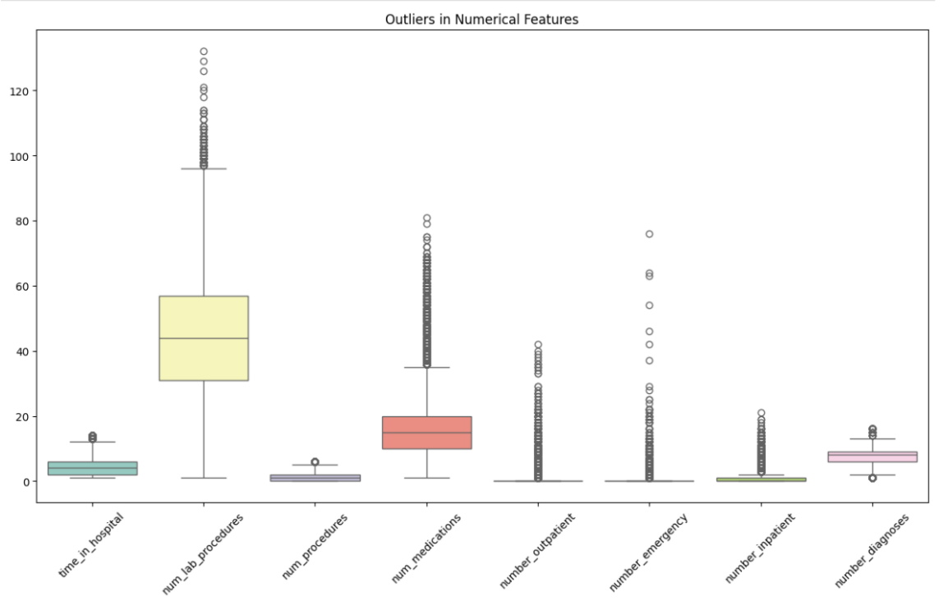
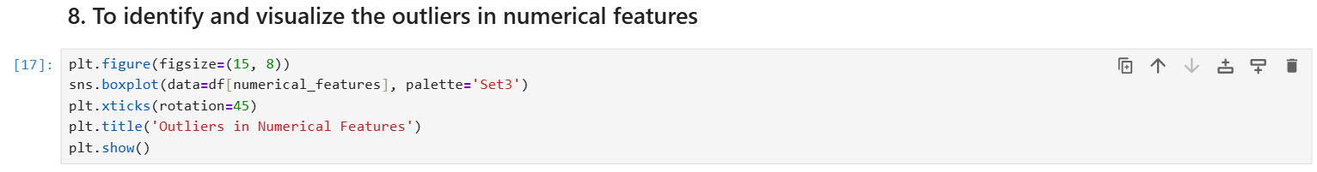
- To identify and visualize any outliers in the dataset, especially in numerical features

The boxplots identify "super-utilizer" outliers, such as patients with up to 76 emergency visits and 21 inpatient stays per year. We also see extreme clinical complexity in patients taking as many as 81 medications and undergoing 132 lab procedures during a single encounter. By flagging these high-utilization patterns, the system can proactively manage these high-risk cases to reduce both patient risk and hospital costs.
From the above EDA analysis, the following information was found –
- High-Risk Profiles: Elderly patients (ages 70–90) with heart-related complications and multiple diagnoses are the most likely to be readmitted.
- Super-Utilizers: A small group of "outlier" patients with extreme counts—up to 76 emergency visits and 81 medications—represent the highest cost and urgency for the system.
- Operational Triggers: Most readmissions stem from unstable emergency arrivals and complex transitions to home health care, where medication changes are frequent.
- The System Goal: By targeting these high-complexity outliers rather than just the "average" patient, the ReadmitGuard system can proactively prevent crises, save lives, and significantly reduce hospital expenses.

Tableau Tasks:
- Interactive Dashboard Design in Tableau:

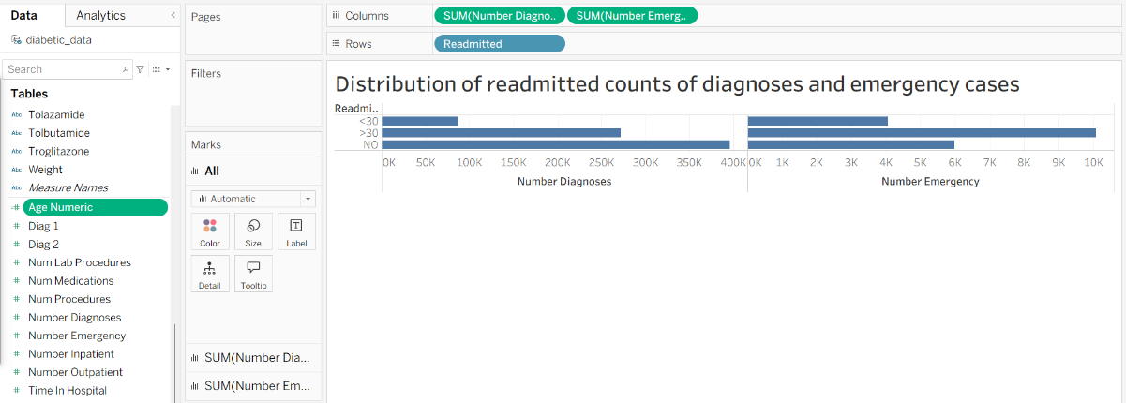
- The distribution of readmitted counts of diagnoses and emergency cases through bar graphs

Here the patients who are readmitted (especially in under 30 days) typically have a higher overall clinical load, requiring more medications and diagnoses. While the "NO" group has a higher total volume because it contains more patients, the readmission categories represent the highest risk and cost per encounter. Time in Hospital and Emergency cases are the most significant visual warning signs, indicating that patients with longer stays or urgent histories are the most likely to return.
- To create a visual capturing age bucket count by readmitted
Here the original project instruction for Age Numeric was mentioned to use INT([Age]) assumes that the source data is stored as a simple integer. However, since the diabetic_data.csv set provides age as a string-based range (e.g., (0-10)), the standard INT() function fails and returns a Null value.
To ensure the data is mathematically functional for the Age Bucket logic, I modified the Age Numeric formula to extract the starting integer from the range and calculate the midpoint (e.g., converting (0-10) to 5).
Formula used - INT(SPLIT(REPLACE(REPLACE([Age], '(', ''), ')', ''), '-', 1)) + 5
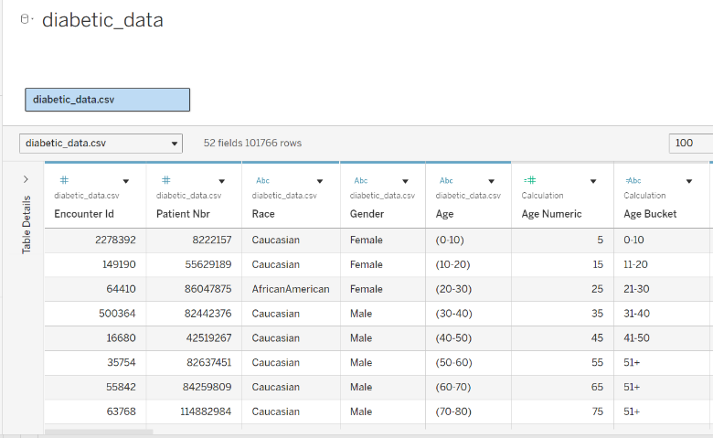
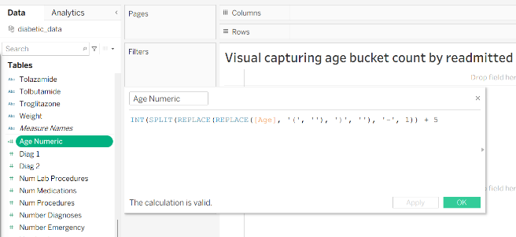
This adjustment maintains data integrity while allowing Tableau to work accurately.
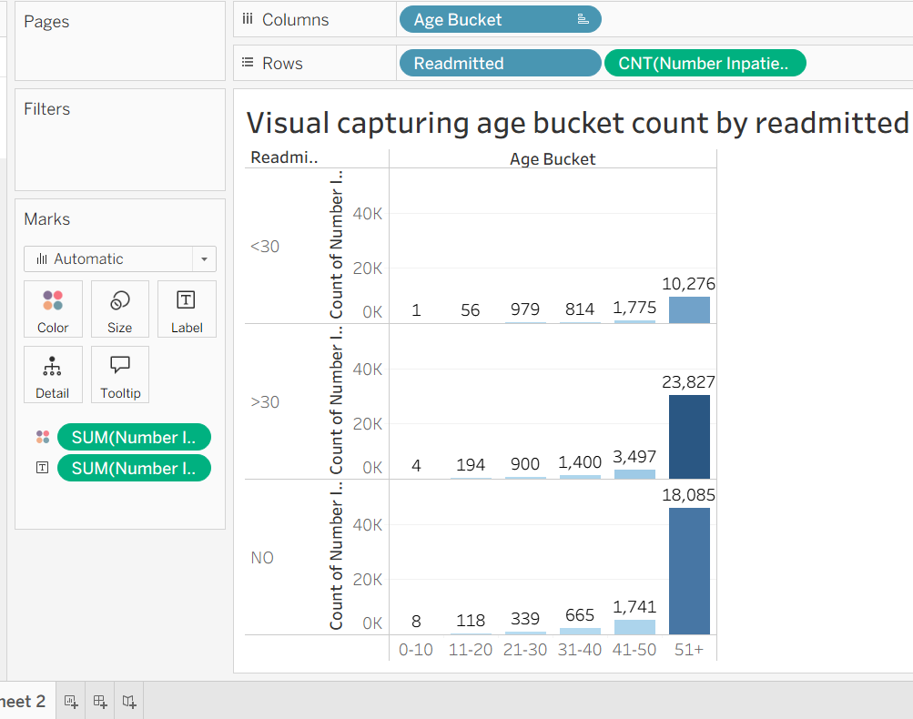
Here in the above graph, the "51+" age bucket is the largest by far, accounting for the vast majority of all hospital encounters in this dataset. The count of Inpatient stays is highest in the older age groups. This suggests that as patients age, they not only visit the hospital more often but are also the primary demographic for the readmission problem.
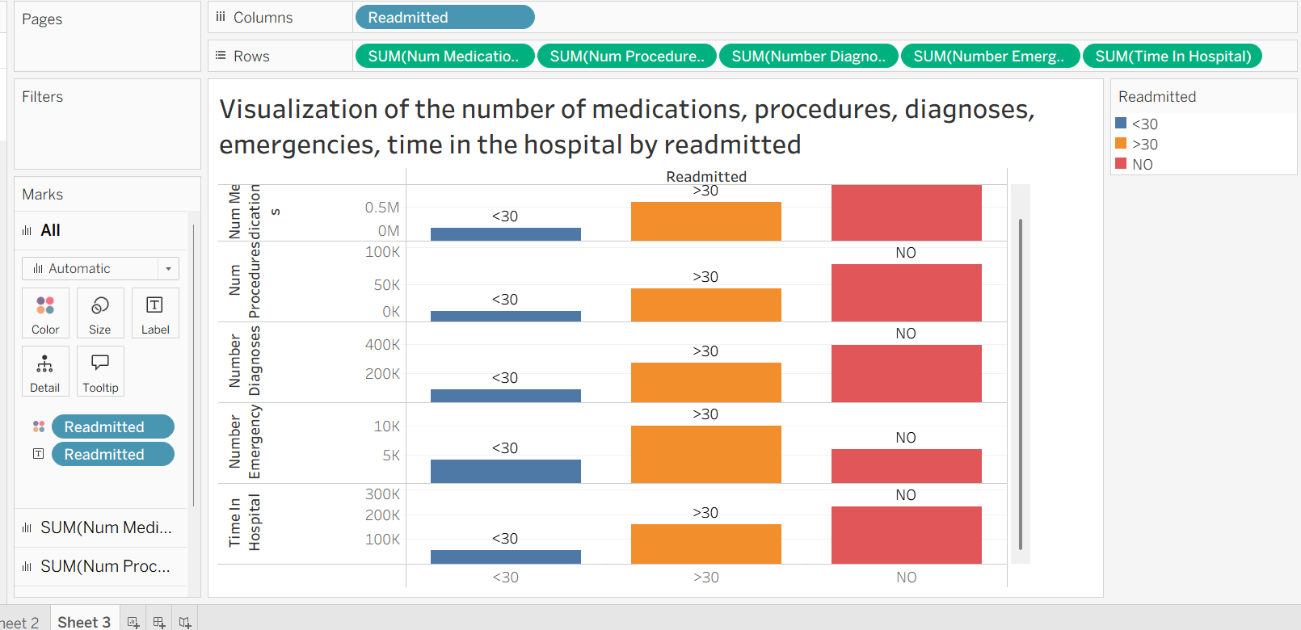
- To visualize the number of medications, procedures, diagnoses, emergencies, time in the hospital by readmitted

This chart shows that patients who were readmitted (either <30 or >30 days) consumed more resources across the board—including more Medications, more Time in Hospital, and more Diagnoses—than those who were not readmitted. Time in Hospital and Number of Medications appear to be the strongest visual indicators of whether a patient might return, as these bars are significantly taller for readmission categories.
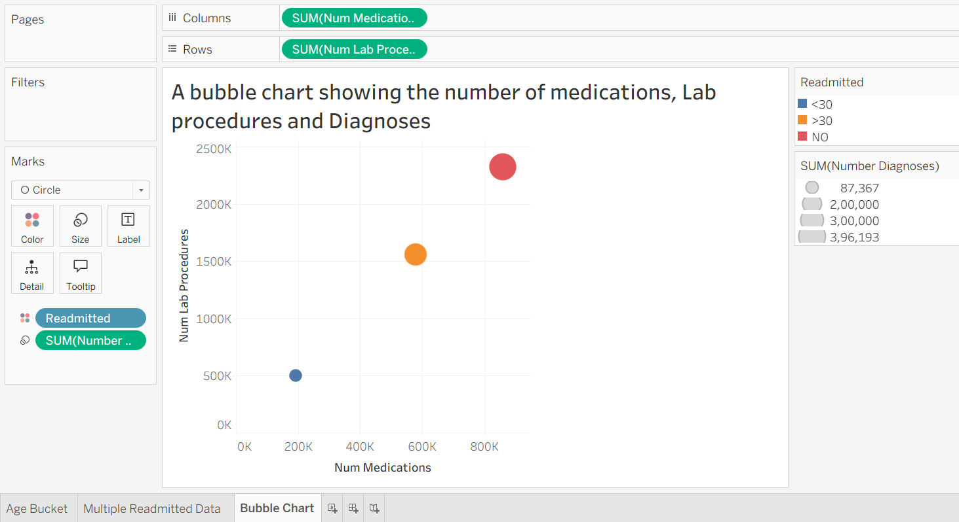
- To create a bubble chart showing the number of medications, Lab procedures and Diagnoses and use Readmitted as color code
The bubble chart visualizes the intensity of care. There is a clear positive correlation between Number of Medications and Lab Procedures. As one increases, so does the other, representing high clinical intensity. Larger bubbles (higher Number of Diagnoses) are predominantly located in the high-medication and high-lab-test area. The color coding shows that readmitted patients often fall into these high-complexity clusters, suggesting that being "medically complex" is a major driver of 30-day returns.
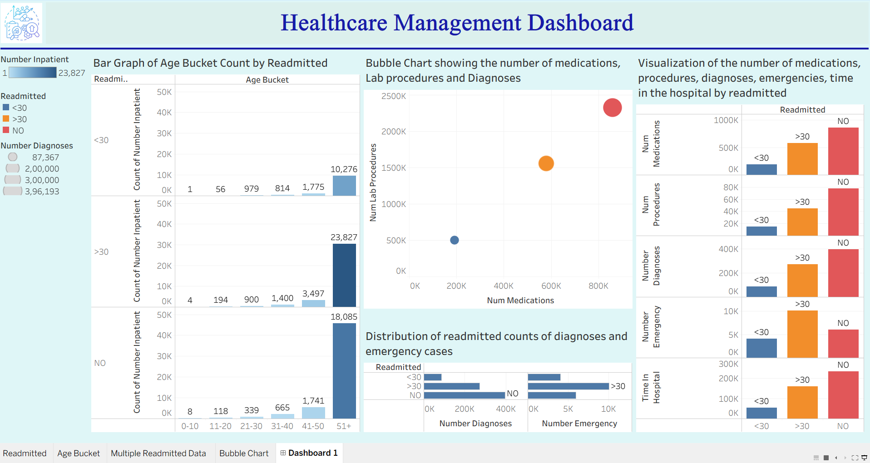
The Final Dashboard showing the Readmitted, Age Bucket, Multiple Readmitted Data, and Bubble Chart made in Tableau

This project has proven that patient readmission follows predictable patterns rather than random chance. From the analysis we have identified that patients over 50 years old with multiple health conditions and a history of emergency visits are the most likely to return within 30 days. The data specifically shows that high medication counts and frequent lab tests are the primary for high-risk cases.
By utilizing these insights, healthcare providers can now proactively intervene with these patients before they are even discharged. This data-driven approach allows the hospital to provide more personalized care, which ultimately saves lives, reduces operational waste, and significantly lowers healthcare costs.

